Asimov on Chemistry, Doubleday 1974 First Edition First Print. As new unclipped dust jacket price $8.95. Art by David November. As new hardcover with all 267 pages tightly bound and no marks of any kind. 8vo ISBN 0385041004

ID 000356 Price $145 Box 7

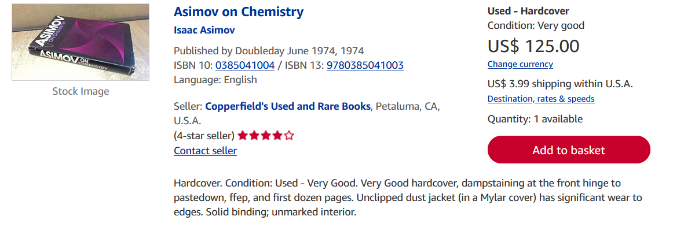
AbeBooks
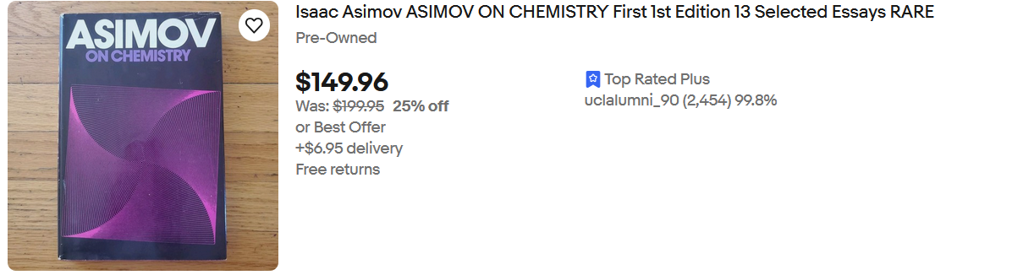ebay

